# Buehler SimpleMet 1000 Mounting Press

**Standard Operation Procedure**

1. Mounting Press Layout

Lower platen controls

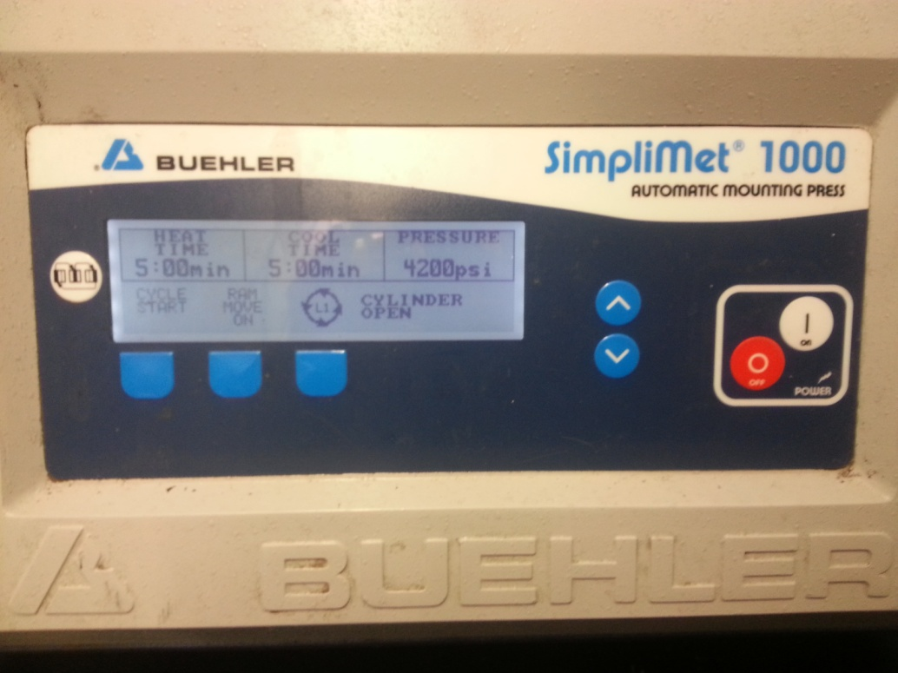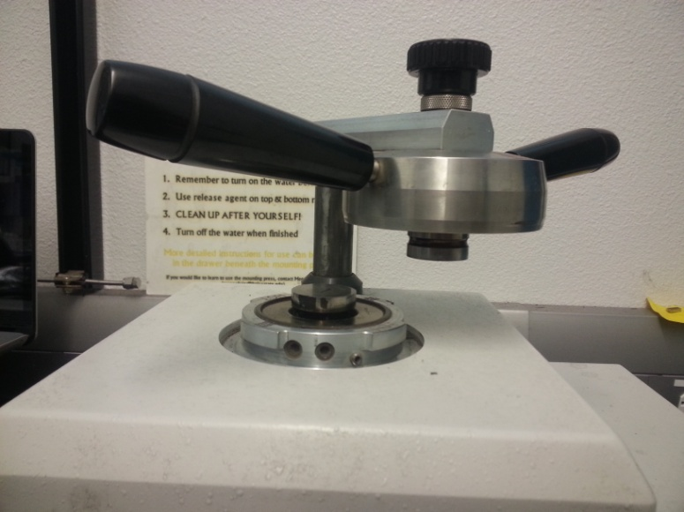

Lower Platen

Handles

Upper Platen

Power Buttons

Program Screen

(should not need changed)

1. Mounting Press Operation
   1. Turn on Mounting Press
   2. Use the platen control buttons to raise the lower platen till it is at the top of the machine.
   3. Check to see that the top and bottom platens are free from left over mounting compound.
   4. Use the liquid release agent (located in drawer) to coat the upper and lower platens
      1. This is a crucial step to ensure that the sample does not get stuck in the mounting press
   5. Place sample on the center of the lower platen with the face of interest down.
   6. Lower the lower platen slightly and add a little mounting compound without knocking the sample over (this ensure that when more compound is added, the sample won’t get knocked over).
   7. Lower platen more and add about a scoop of the mounting compound.
   8. Lower platen into the machine enough that the top platen can be pushed down and locked into place.
   9. Push top platen down and turn handle clockwise to lock into place
   10. Push the start button
       1. The mounting process takes about 20 minutes (pre-programmed)
   11. Once the process is complete (indicated by a beep) unlock the top platen and lift up
       1. If it is stuck, raise the lower platen to push the top platen out of the machine.
   12. Remove sample and clean up and left over mounting compound.
   13. Turn off mounting press